

**THE UNIVERSITY OF DANANG**

**UNIVERSITY OF SCIENCE AND TECHNOLOGY**

**Faculty of Mechanical Engineering**

PBL 3 MICROCONTROLLER AND SENSOR APPLICATION MESSAGEDESIGN

**TOPIC: PARKING LOT IN ZONE F**

**Instructor: Assoc. Prof. Dr. DANG PHUOC VINH Student: NGUYEN VAN THANH**

**LE ANH TUAN**

**PHAN DANG DANH**

**Class: 21CDTCLC1 (21.05A)**

**Da Nang, June 2024**

# TABLE OF CONTENTS

TABLE OF CONTENTS 2

PREFACE 3

CHAPTER I: INTRODUCTION 4

1. Introduction about manage by fingerprint sensor system 11
2. The components are used for the topic 11
   1. Microcontroller PIC16F877a: 11
   2. Servo 15

3. MAX232 20

CHAPTER II: HARDWARE DESIGN 21

1. Introduction of Altium Designer: 21
2. Main circuit and Power circuits 22

CHAPTER III: CSS SOFTWARE 25

* 1. Introduction of CCS Software: 25
  2. Flowchart 26
  3. Code 27

CHAPTER IV: VISUAL STUDIO 29

1. Introduction of Visual Studio Software 29
2. Flowchart 29
3. Display: 31

# PREFACE

Microcontrollers and industrial sensors stand at the forefront of modern science and engineering. Integrated into contemporary circuit boards, microcontrollers enable precise movements and robust processing capabilities, driving the evolution of electronic devices towards greater intelligence for Industry 4.0. Likewise, industrial sensors continue to advance, with manufacturers constantly enhancing their accuracy and functionality.

Mastering the utilization of sensors and microcontrollers is pivotal for students, empowering them to apply this knowledge practically. Through a project-based approach, students can merge their understanding of these two fields to program systems aligned with real-world applications. Such projects not only deepen theoretical understanding but also foster hands-on experience crucial for navigating the complexities of modern technology.

Guided by the dedicated mentorship of Mr. Dang Phuoc Vinh, students embark on a journey of exploration and innovation, culminating in the successful completion of their course projects. We extend our heartfelt gratitude to Mr. Vinh for his unwavering support and invaluable guidance throughout this endeavor.

**Student group made**

**Nguyen Van Thanh Phan Dang Danh Le Anh Tuan**

# CHAPTER I: INTRODUCTION SMART PARKING A LOT

* 1. **General Introduction to Modern Smart Parking Lots**

A smart parking lot is a system that utilizes advanced technologies to automate the management and control of parking. This system can help solve issues related to parking shortages, traffic congestion, and vehicle security.

* + 1. Common Types of Smart Parking Lots
* There are many different types of smart parking lots, but some of the most common include:

|  |  |  |
| --- | --- | --- |
| • | **Guidance Systems** | : These use electronic signs to direct drivers to available |
| parking spots. | | |

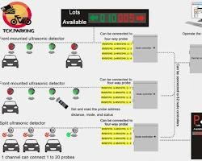

### Automated Payment Systems: These allow drivers to pay for parking using credit or debit cards without needing to go through a toll booth.

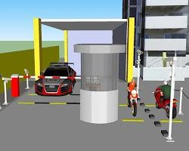

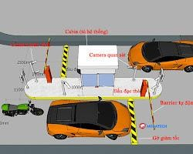

and exit from the parking lot, allowing access only to authorized

**Access Control Systems:** These use cameras and sensors to monitor entry

**.**

|  |  |  |
| --- | --- | --- |
| • | **Surveillance Camera Systems** | : These help monitor the security of the parking |
| lot and record footage in case of incidents. | | |

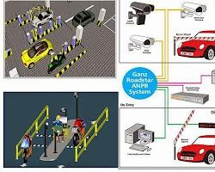

**Reservation Systems:** These allow drivers to reserve parking spaces in advance via the internet or a mobile app.

### Automated Parking Systems: These use robots to automatically move cars to and from parking spaces as needed.

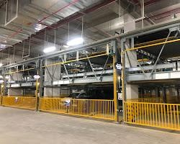

1. **Benefits of Smart Parking Lots**

### Smart parking lots offer numerous benefits for both drivers and parking lot owners.

**For Drivers:**

### Time Savings and Reduced Stress: They save time and reduce stress when searching for parking spots.

**Easy and Convenient Payment:** Payments are easy and convenient**. Enhanced Security:** Improved security for vehicles**.**

### Vehicle Tracking: Ability to track the location of their car within the parking lot.

**2.For Parking Lot Owners:**

### Increased Space Utilization Efficiency: Smart parking lots optimize the use of parking space, allowing for more vehicles to be accommodated efficiently.

* **Reduced Operational Costs**: Automation and efficient management lead to lower operational expenses, such as manpower and energy costs.

### Increased Revenue: With features like reservation systems and dynamic pricing, smart parking lots can generate additional revenue streams.

* **Improved Image:** A smart parking lot reflects positively on the overall image of the parking facility and its owner, leading to better customer satisfaction and loyalty.

3.Smart parking is a rapidly developing field with significant potential for

the future. Emerging technologies such as artificial intelligence, machine learning, and the Internet of Things (IoT) are being employed to develop more advanced, efficient, and secure smart parking systems.

### 4.Some Applications of Smart Parking Lots in Da Nang

### Coopmart Supermarket Parking Lot - 478 Dien Bien Phu Street

### University of Education - University of Da Nang Parking Lot

### Go! Supermarket Parking Lot - 257 Hung Vuong Street

### Lotte Supermarket Parking Lot - 6 Nai Nam Street

**II. Current Situation of Parking Lots in Area F**

### 5.Severe Shortages:

* **High Parking Demand:** The large number of students and the increasing popularity of personal vehicles have led to a high demand for parking at the school, exceeding the capacity of traditional parking lots.

### Limited and Disorderly Parking Spaces: The limited space of the parking lot cannot accommodate all vehicles, leading to overcrowding, queues, and potential collisions.

### Inadequate Security: Manual management systems and lack of surveillance cameras create conditions for theft and vehicle swapping.

### Environmental Impact: Exhaust emissions from motorcycles due to traffic congestion in the school area contribute to increased environmental pollution

* **Students**: Waste time searching for parking spots, impacting class schedules and academic focus. Worried about vehicle security, with potential risks of property loss.
* **School**: Image is affected, facing difficulties in traffic management and ensuring security in the school area.
* **Traffic congestion**: Vehicles parked indiscriminately, causing urban aesthetics to deteriorate and affecting general traffic flow.

### Conclusion: Due to the difficulties at the parking lot in Area F, we have come up with the idea of implementing smart parking solutions into the Area F parking lot in this PBL3 project. This project aims to address and bring about the following benefits:

* **Automation of Processes:** Implementing guidance systems, automated payment, and card-based access control will save time, reduce congestion, and enhance security.

**III. Smart Surveillance and Management:** Enhancing security to ensure the safety of students' vehicles and property,Parking lot in Area F automates the management of vehicle entry and exit.

### Devices Used:

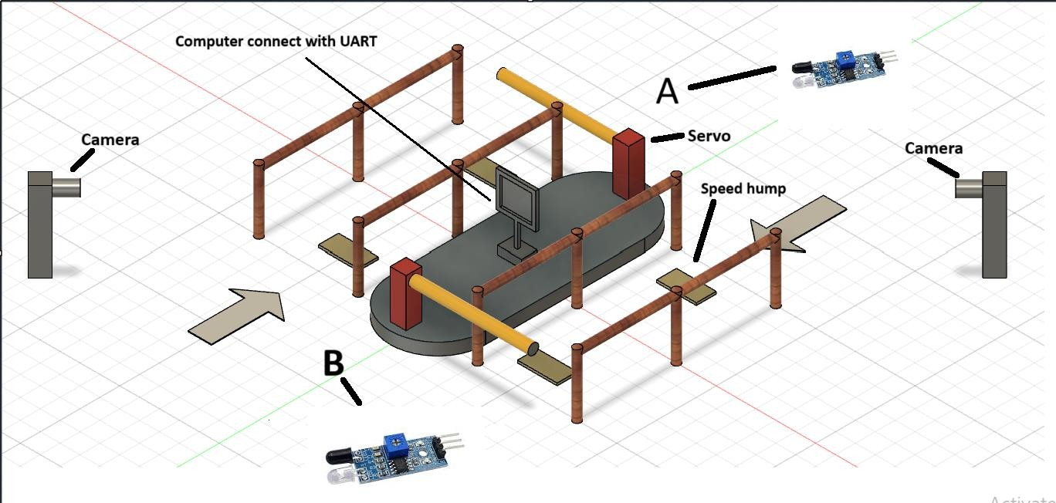

**Camera Infrared sensor Servo motor Push button**

### PIC16F877A microcontroller LED

**RFID card**

### The number of pins connected to the microcontroller for each device: Crystal oscillator circuit: 2 pins - CLKIN, CLKOUT

**Reset circuit:** 1 pin - MCLR **UART circuit:** 2 pins - Tx, Rx

### PicKit3 circuit: 4 pins - MCLR, PGC, PGD, PGM, and 2 power pins with ground

**2 servo motor circuit:** 2 pins - RC1, RC2

### 2 infrared sensor circuit: 2 pins - RC0, RC5

**4 push button circuit:** 4 pins - RB1, RB2, RB3, RB4 **2 LED circuit**: 2 pins - RD6, RD7

### System Program:

Entry block system (A0) Vehicle detection system (A1)

### Automatic vehicle image capture system (A2) RFID card scanning system (A3)

Automatic payment system (A4)4**.**

### Entrance Gate:

* The driver approaches and scans the card.

### The camera captures an image and saves it corresponding to the card number.

* The barrier opens for the person to enter. At this point, the sensor detects if the person has passed through the barrier area. If not, the barrier remains open.

### Exit Gate:

* + The driver approaches and swipes the card.
  + If the card number exists in the storage, the camera captures an image
  + The system compares the license plate number with the card number.
  + If correct, the barrier opens for the exit; if incorrect, the barrier remains closed.
  + The sensor operates similarly to the entrance gate.
  + If the card number does not exist in the storage, the gate remains closed.

### Peripheral Devices Operation: Manual close button:

When the barrier is opening and the sensor detects someone in the barrier area, the gate will not close. It will close automatically when no one is detected, or manually upon pressing the button.

### Infrared sensor:

When someone swipes the card correctly and passes through the barrier area, the sensor detects their presence, and the logic level changes from 0 to

### The barrier cannot close until the sensor no longer detects anyone. Manual open button:

PART II: PIC16F877A MICROCONTROLLER AND PERIPHERALS

### Introduction about manage by fingerprint sensor system:

In this day and age, Today, product classification has been applied a lot in practice. In the era of industrialization, machines are gradually replacing human labor, which is an important component in production lines or jobs requiring high precision. Therefore, the introduction of an automatic product identification and classification system is an inevitable development to meet life's needs.

Depending on the complexity of the classification requirements, the automatic classification systems have different large and small scales. However, there is a common feature that the cost of these systems is quite high, especially given the economic and scientific and technological conditions of Vietnam. Therefore, at present, product classification is only used in factories with complex systems. While most Vietnamese enterprises still use workers for direct classification.

The product classification system was born to solve repetitive tasks with high accuracy. Product classification has many types such as classification by height, by color, classification by barcode, classification by image....

#### The components are used for the topic:

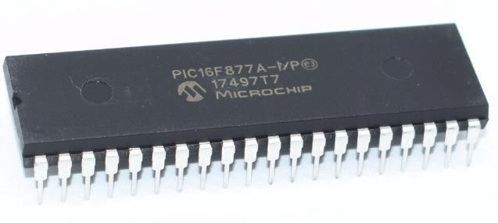

*Figure 1.1. PIC 16F877A*

#### Microcontroller PIC16F877a:

* + - 1. **Introduction to PIC 16F877A:**

PIC 16F877A is a microcontroller chip produced by Microchip, belonging to the PIC family. PIC 16F877A has 40 pins, divided into 5 ports from A to E. Among them, 33 pins are I/O, 3 programmable timer/counter modules, internal and external interrupts (2 instructions on one interrupt vector), USART serial communication protocol (RX, TX),

SPI (SDO, SDI, SCK, SS), I2C PIC 16F877A.

All pins of the PIC have the ability to supply and withdraw a current of about 25mA, enough to drive 2 parallel LEDs. However, the limit of each PORT (8 pins) is only 90mA. Therefore, when designing, it is necessary to calculate to avoid overload for each pin (over 25mA) and avoid overload for the entire PORT (90mA).

PIC 16F887 is used in most industrial applications as a control device. Moreover, it is an ideal microcontroller because it has many ADC channels that are applied in automotive systems.

#### Pinout of PIC 16F877A:

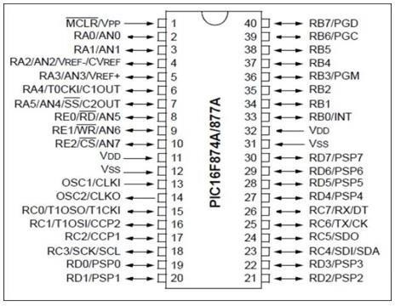

*Figure 1.2. PIC 16F877A pin-out*

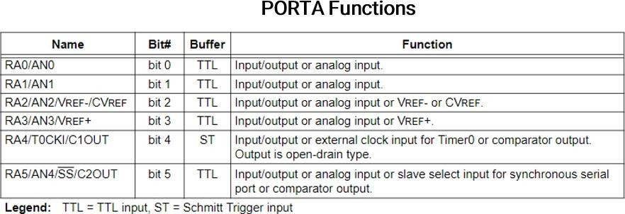

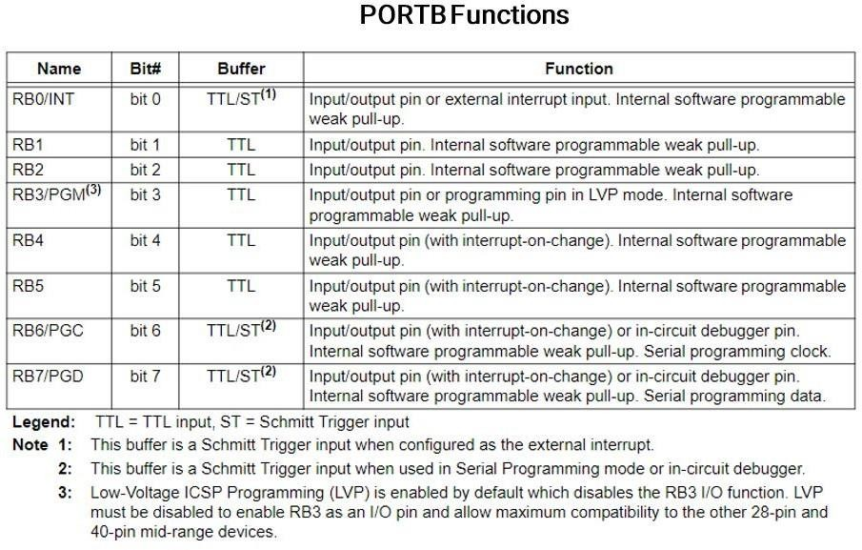

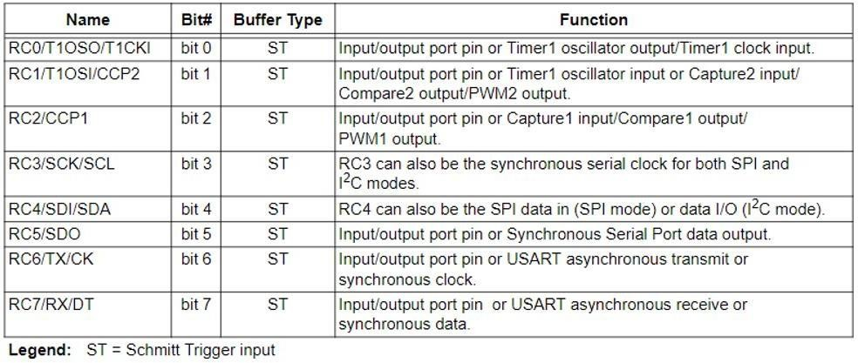**PORTC Functions**

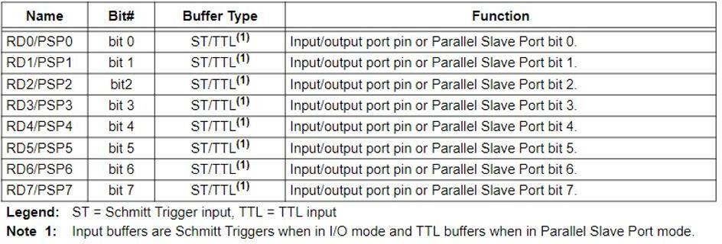**PORTD Functions**

## PORT E Functions

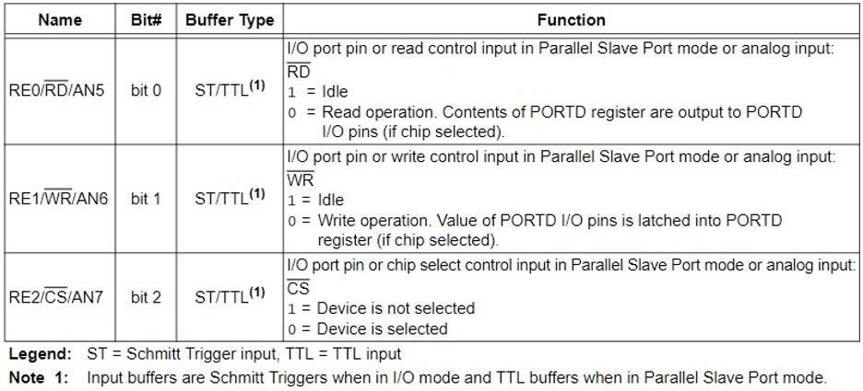

#### Servo

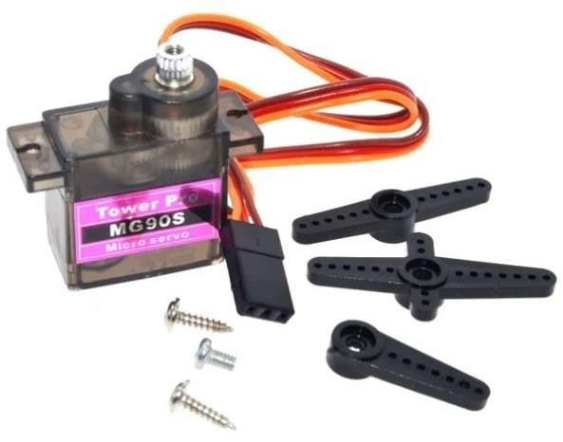

**What Are Servo Motors?**

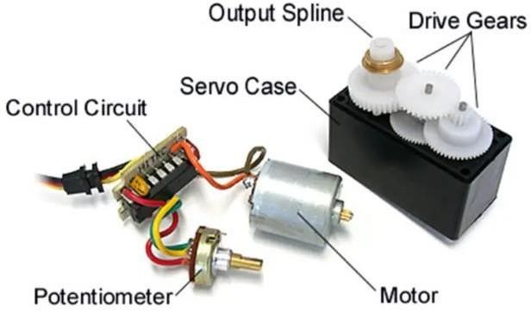

14A servo motor is a closed-loop control system consisting of a DC motor, gearbox, and potentiometer to provide feedback information about the angular position of the motor to be controlled. Servo motors are typically used in applications where precise small angular motion is required.

Servo motors are widely used in robotics, automation, and electromechanical systems in general. Which includes: robotic arms, small bots, hexapods, and bio-inspired robots, and much more…

Hereafter in this article, we’ll discuss how servo motors internally work and how to control servo motors with microcontrollers & even without using a microcontroller in order to test your servos on the bench for the purpose of verification. Sometimes you get defect parts and sometimes the timing diagrams given in datasheets are not the exact ones for a specific model of a servo motor.

How To Control Servo Motors?

The way servo motors are working is simply by comparing a reference voltage to the actual angular shaft position using a potentiometer attached to the gearbox. The reference voltage can be controlledby sending a 50Hz PWM (pulse-width-modulated) signal to the servo motor. Which in turn changesthe reference voltage and the control circuitry steers the motor in the right direction until it reaches the exact required angle position and it keeps holding it while the PWM signal is not changing

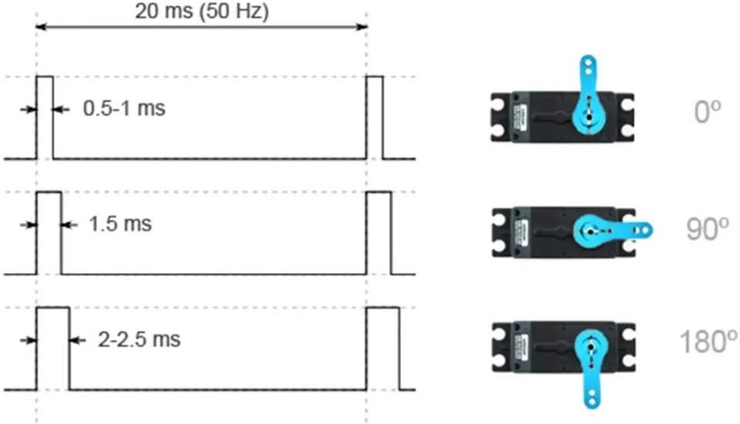

The diagram down below indicates the behavior of the servo motor’s shaft due to the change of the PWM pulse width. Typically the full sweep (0-

>180°) is achieved by sweeping the pulse width from(1ms to 2ms).

Different servo motors have different ranges for the pulse width of the 50Hz PWM signal which corresponds to the 0° position and 180° maximum angular position.

So, it’s important to double-check the datasheet for the specific servo motor you are using. However,it’s always best to take a test on the bench yourself because some servos come with a couple of Chinese papers that are poorly translated to English and may not be the exact documents for the attached servo motor at all!

And you’ll end up trying to figure out why your servo motor is not sweeping over the full scale usingthe values found in the “DATASHEET”.

Testing Servo Motor Without Microcontroller

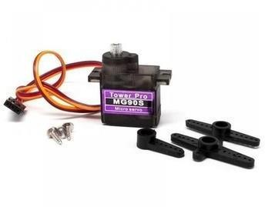

That’s the servo motor we’ll be using in this tutorial. The first search result that popped up in my facewhen i was googling for its datasheet was a document that turned out to be not so accurate in terms of the timing diagram for the PWM signal. Here is the diagram snippet from the datasheet.

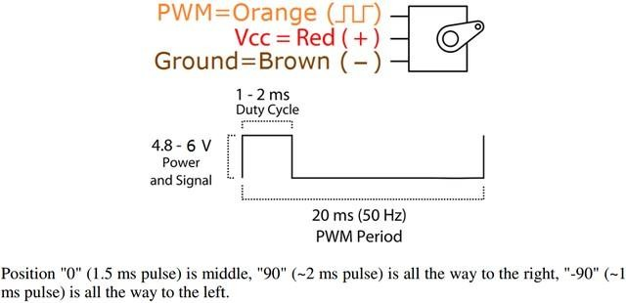

And it turned out that the correct range for the PWM pulse width is 0.6ms to 2.4ms for angular motionfrom 0° to 180°. And that’s what we’ll be using for the test without and with a microcontroller.

#### Note That:

* **0.6ms of 20ms period is a 3% duty cycle (0° Position),**

#### 1.4ms of 20ms period is a 7% duty cycle (90° Position),

* **2.4ms of 20ms period is a 12% duty cycle (180 ° Position).**

Speaking of the no-microcontroller test, you can use the bench signal generator to generate the required 50Hz PWM signal for the servo motor. And here are the functional settings I’ve programmed my DDS generator to perform.

* + Square wave output signal 0-5v
  + Fixed frequency 50Hz
  + Sweep Function Activated for (Duty Cycle), Start value is 3%, End Value is 12%, Time periodis 2 Seconds

Servo Motor Control With PIC Microcontrollers

There are different ways to generate the 50Hz PWM signal required by the servo motor using a microcontroller. Speaking about PIC microcontroller, the first thing that should pop-up in your mind is the CCP PWM hardware module inside the microcontroller itself. But it turns out to be a little bit tricky business to get that right, here is why!

#### Why Is It Challenging To Use CCP PWM In PIC Microcontrollers To Control Servo Motors?

The problem stems from the fact that the timer2 period register used by the CCP PWM is an 8-Bit register and it can reach up to 255 at maximum. And here is the formula for the PWM frequency

Let’s use the highest Prescaler possible (16) and the lowest Fosc you might have got (4MHz). The desired period is (1/50) to get 50Hz PWM Signal. Hence, the only unknown is the value to be written in PR2. By solving for PR2, it turns out to be 1249!! which is definitely way more than an 8-Bit (PR2) register can handle!

Even with a moderately low frequency (4MHz) oscillator, we still can’t generate a PWM signal that has a very low frequency near the 50Hz range. That’s the challenge!

One simple solution (at least cheap in code) is to settle down for the internal low- frequency low- power RC oscillator (31250Hz) inside the microcontroller itself. By plugging this Fosc=31250 in the previous PWM period equation, the PR2 value will be 155! And that’s obviously in the 8-Bit range and achievable.

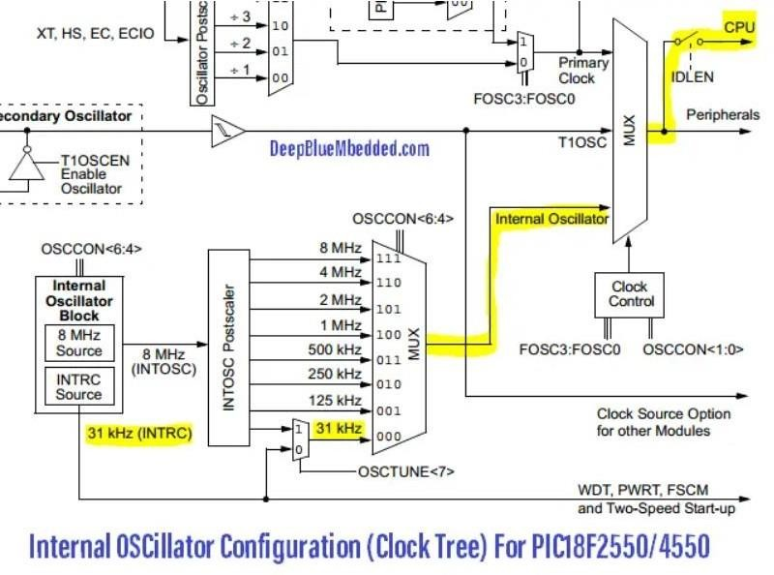

#### MAX232

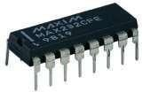

*Figure 6.1. MAX232*

The MAX232 is a 16-pin IC that has SOIC, PDIP and SOP packages. This IC is built for serial communication between PC and microcontroller and converts TTL/CMOS to RS232 logic level. As you know microcontroller use TTL transistor logic or 0 to 5V transistor but in computer RS232 works at -24V or +24V, so we can't interface these microcontrollers directly with computer and we have to require a TTL/CMOS to RS232 logic level converter, so IC MAX232 is built to solve this problem by converting TTL/CMOS to RS232.

To communicate with the User interface we design in the computer weuse IC max232 and com to USB cable.

# CHAPTER II: HARDWARE DESIGN

### Introduction of Altium Designer:



Altium Designer is a robust electronic design automation software suite used for PCB design, schematic capture, and FPGA development. Here are some key features of Altium Designer:

**1.1 Schematic Capture**: Altium Designer provides a powerful environment for creating and editing schematic diagrams. Users can place various electronic components such as resistors, capacitors, ICs, connectors, and more, and interconnect them to define the circuitry.

* 1. **PCB Layout:** Altium Designer offers advanced tools for PCB layout design. Users can translate their schematics into physical PCB layouts, defining the placement and routing of components, vias, traces, and other elements.
  2. **Simulation**: Altium Designer supports circuit simulation, allowing users to verify the functionality of their designs before fabrication. It includes features for analyzing signal integrity, power integrity, and thermal performance.

**1.4. Library Management:** Altium Designer comes with a comprehensive component library and also allows users to create and manage their own component libraries. This ensures easy access to commonly used parts and facilitates design reuse.

* 1. **3D Visualization:** Altium Designer includes a 3D PCB visualization feature, enabling users to view their designs in a realistic 3D environment. This helps in visualizing the physical layout of the PCB and detecting potential issues early in the design process.
  2. **FPGA Development:** Altium Designer supports FPGA development, allowing users to design and implement complex digital systems using FPGA devices. It provides tools for HDL design, synthesis, and verification.
  3. **Design Collaboration:** Altium Designer offers features for collaborative design, allowing multiple users to work on the same project simultaneously. It supports version control and facilitates efficient communication among team members.
  4. **Manufacturing Outputs:** Altium Designer generates manufacturing outputs required for PCB fabrication, including Gerber files, NC drill files, bill of materials (BOM), and assembly drawings. This streamlines the process of transitioning from design to production.

Overall, Altium Designer is a comprehensive electronic design solution that caters to the needs of professional PCB designers, engineers, and researchers, offering advanced features for schematic design, PCB layout, simulation, and collaboration.

### Main circuit and Power circuits

#### Schematic

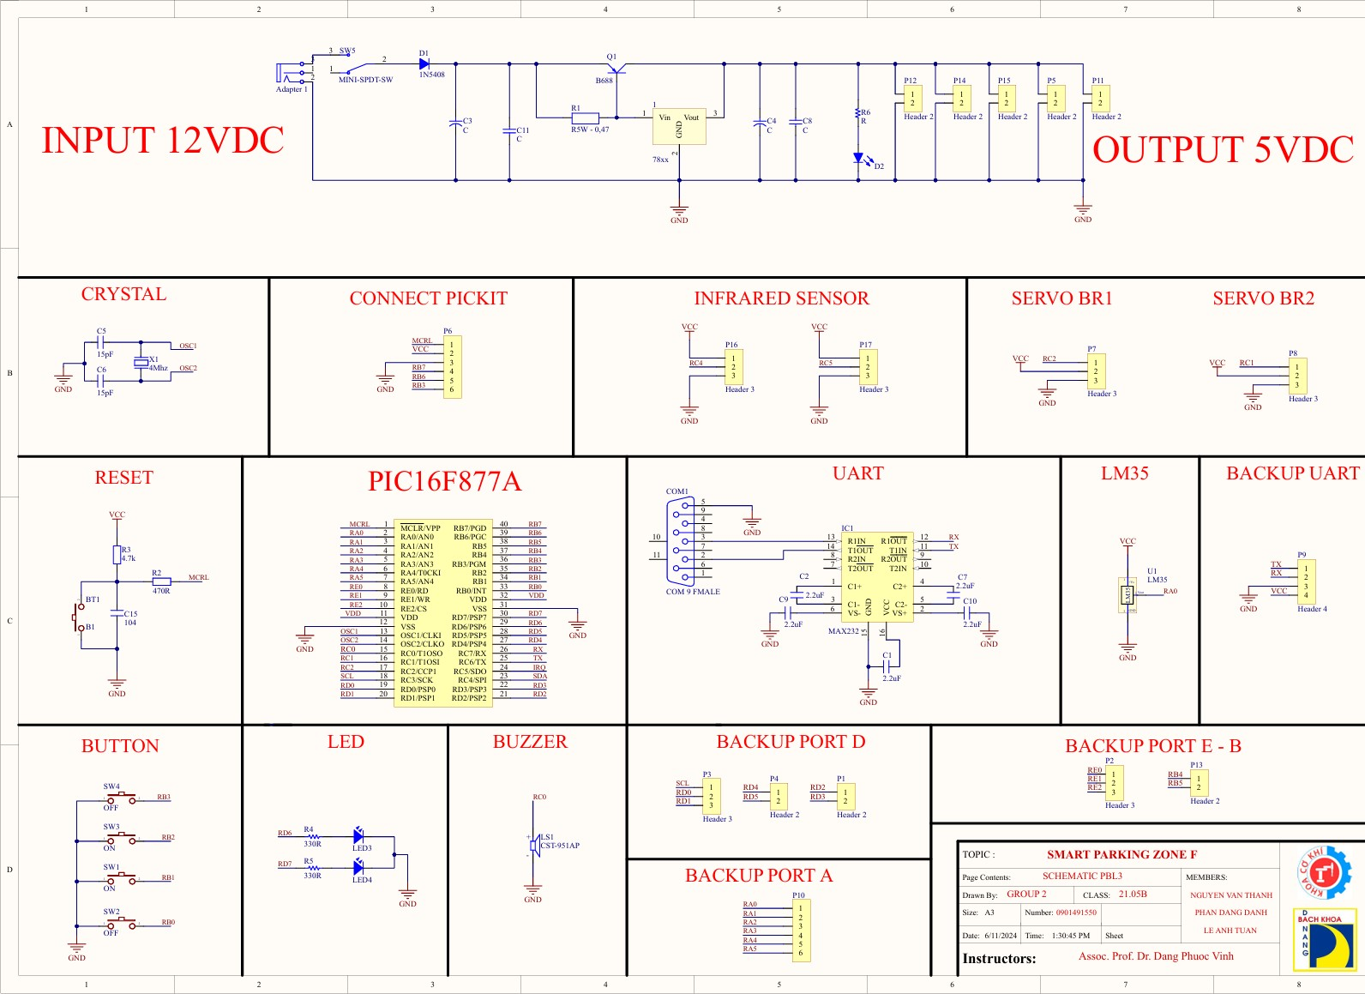

* 1. **PCB Layout**

#### Power circuit

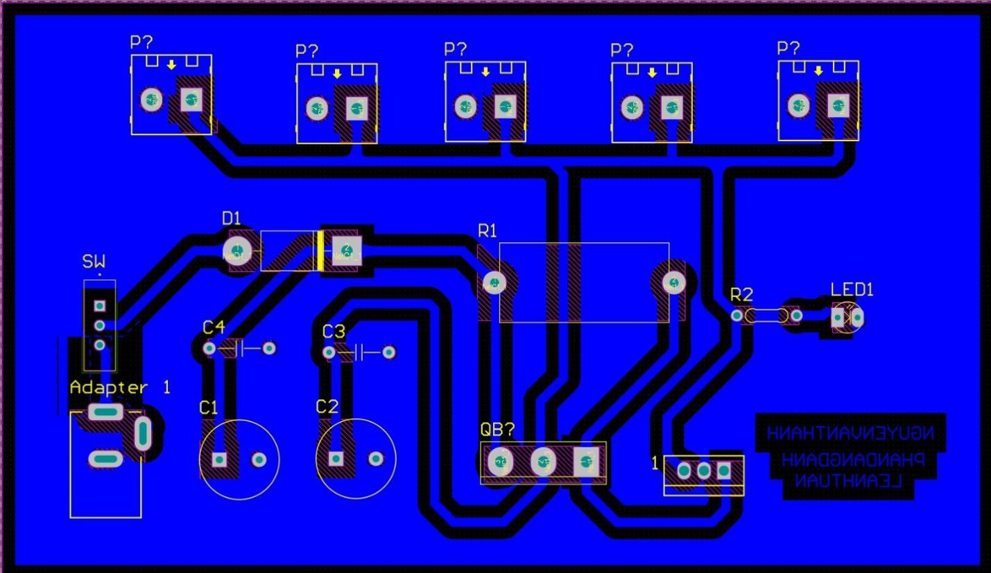

* **Control circuit**

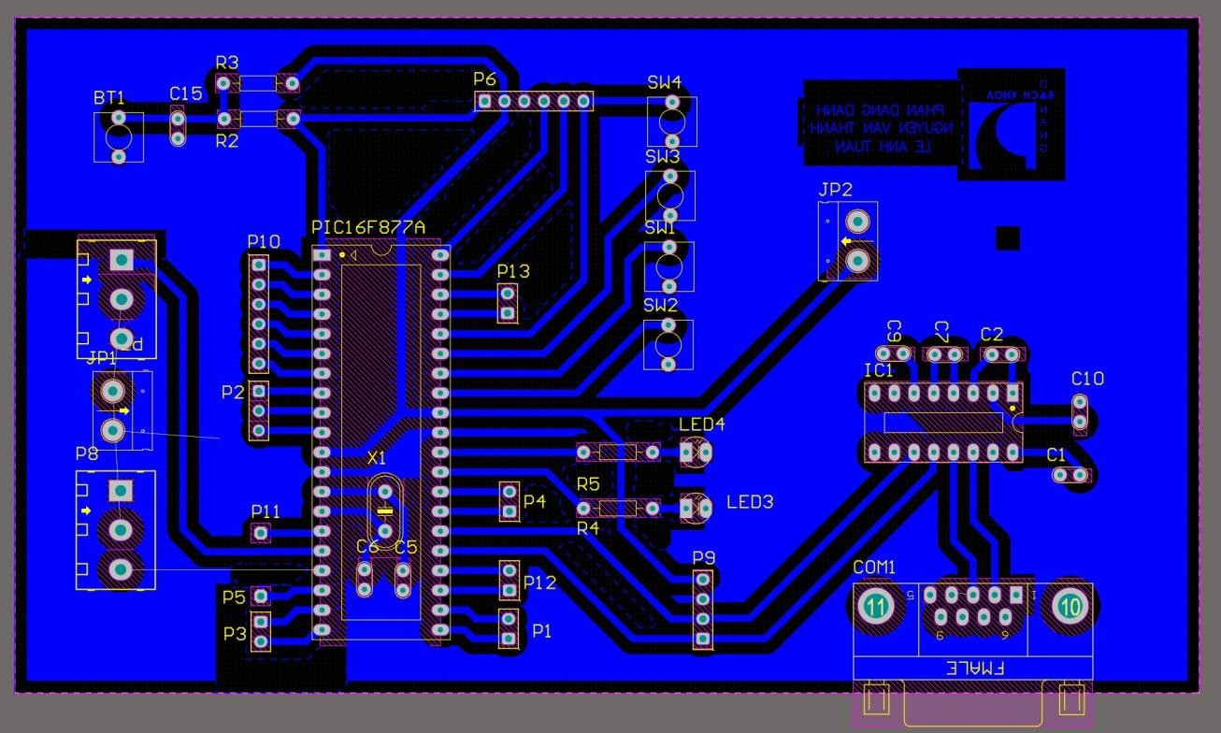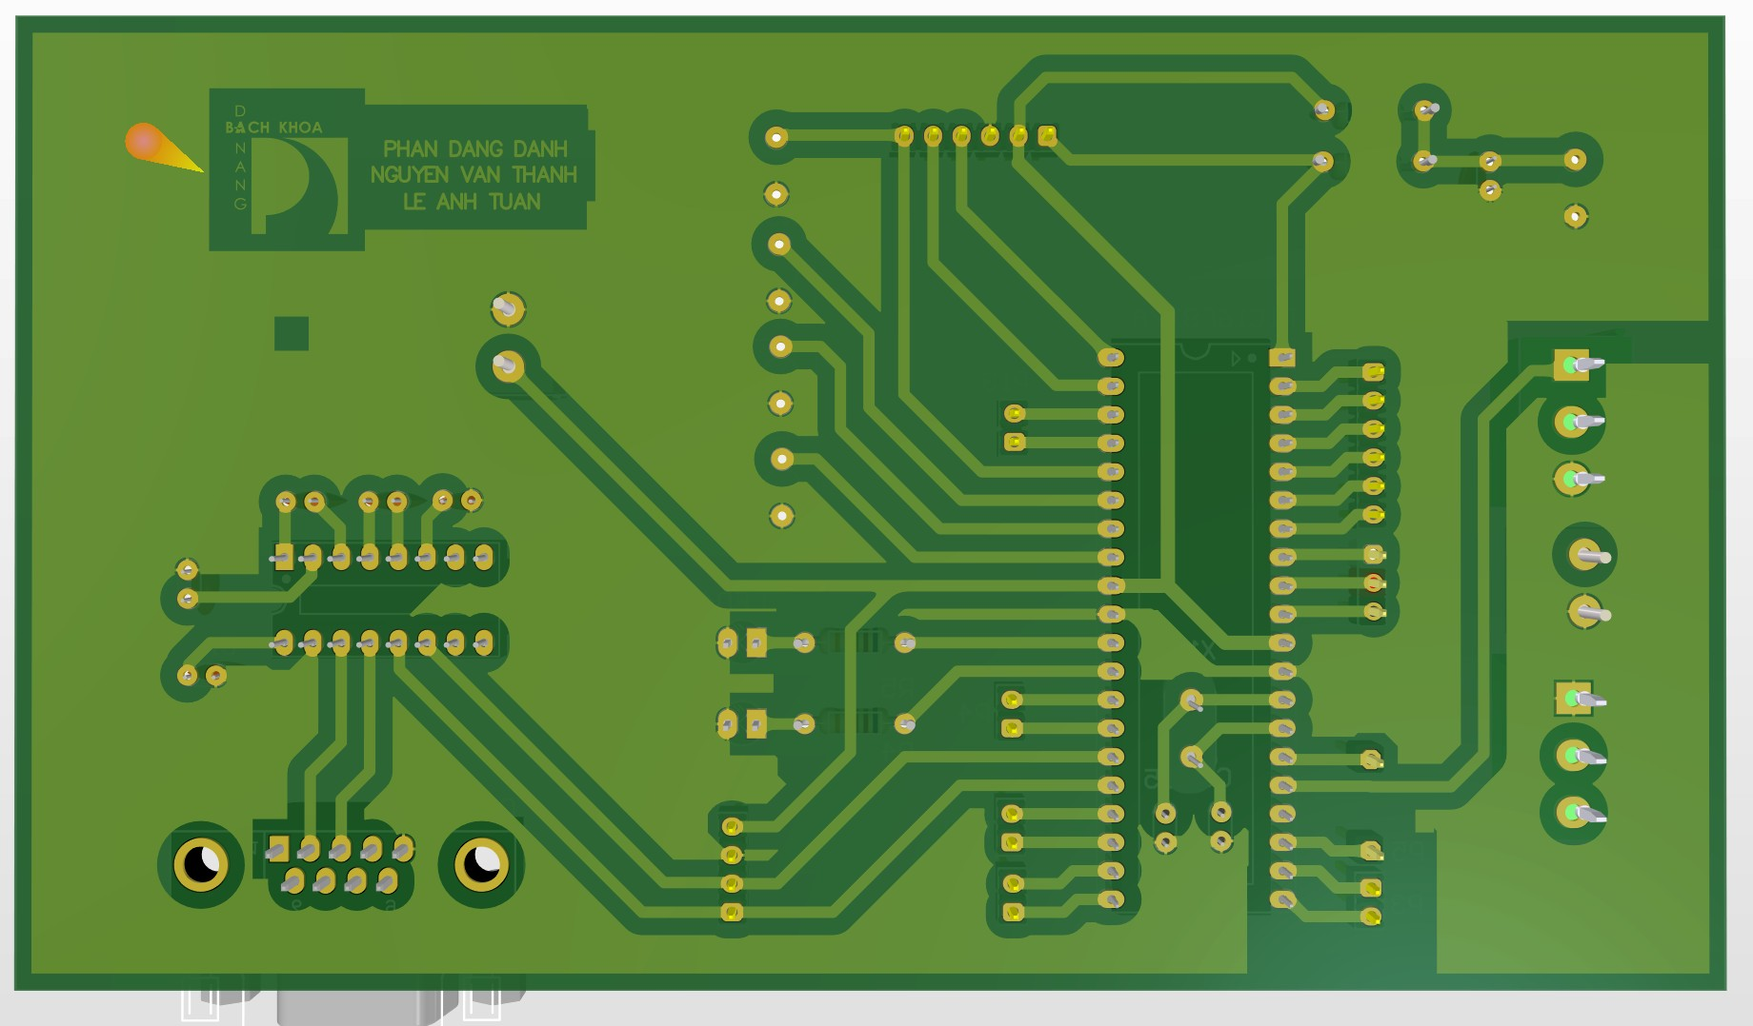

#### Simulation

* **Power circuit**

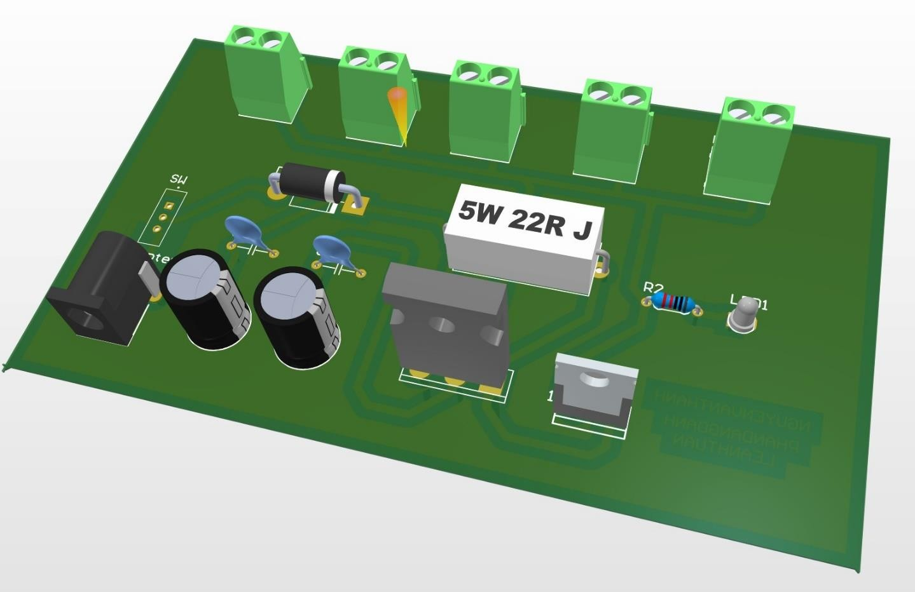

* **Control circuit**

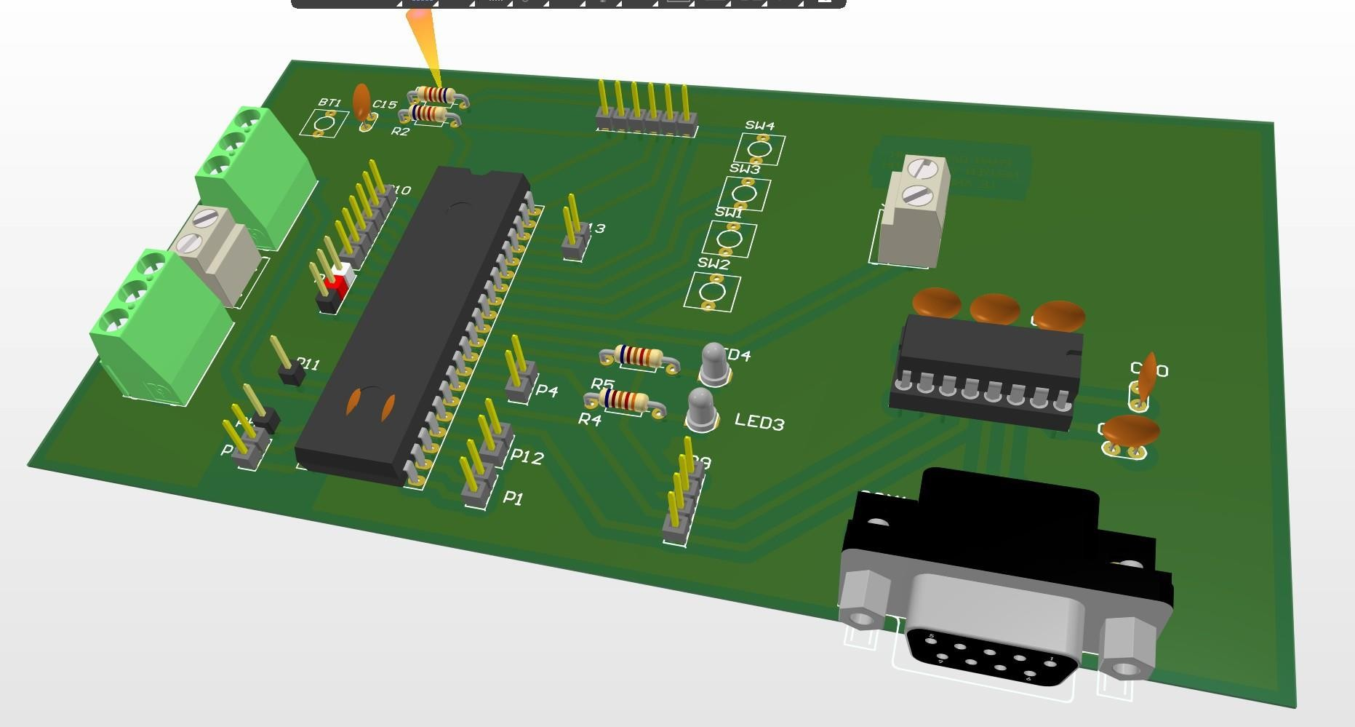

# CHAPTER III: CSS SOFTWARE

#### Introduction of CCS Software:



CCS C is an integrated development environment (IDE) and C compiler made by CCS

Inc. It is mainly used to develop embedded applications.

* It provides features like project management, code editing, syntax highlighting, code completion, integrated debugging, etc. This makes it easier to write, build and debug C code.
* CCS C supports a variety of microcontrollers like PIC, AVR, ARM, MSP430, etc. It can generate object code for the target microcontroller.
* The integrated debugger allows you to set breakpoints, step through code, view variables, view registers, and perform other debugging tasks.
* CCS C comes with a standard C library that provides functions like string manipulation, memory allocation (malloc, free, etc.), input/output and many others.
* You can build applications in CCS C and generate executable files that can be flashed to the microcontroller using a programmer.
* The C compiler implements the C language as defined by the ANSI standard. It follows a standard compilation process of preprocessing, compiling and assembling, and linking.

#### Flowchart

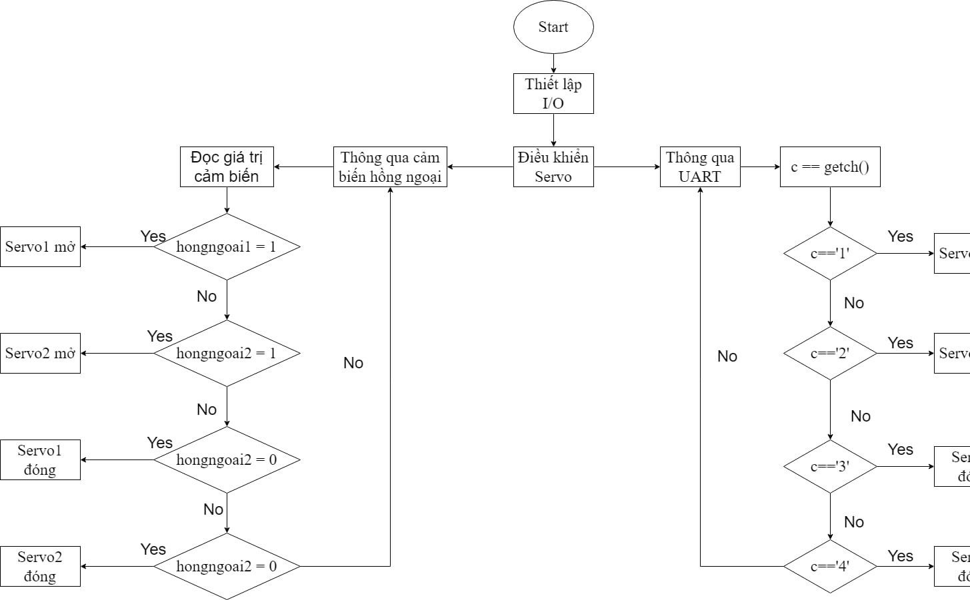

#### Code

**#include <RS232.h>**

**#use rs232(baud=9600,parity=N,xmit=PIN_C6,rcv=PIN_C7,bits=8)**

**#define servo1 PIN_c1**

**#define servo2 PIN_c2**

**#define hongngoai1 PIN_d0**

**#define hongngoai2 PIN_d1**

**int16 angle1,angle2;**

**char c;**

**void control_servo1(int16 time1){**

**output_high(servo1);**

**delay_us(time1);**

**output_low(servo1);**

**delay_us(20000 - time1);**

**}**

**void control_servo2(int16 time2){**

**output_high(servo2);**

**delay_us(time2);**

**output_low(servo2);**

**delay_us(20000 - time2);**

**}**

**void main()**

**{**

**set_tris_b(1);**

**port_b_pullups(1);**

**set_tris_d(1);**

**output_high(PIN_D7);**

**output_low(PIN_D6);**

**while(TRUE)**

**{**

**if(kbhit()) {**

**c=getch();**

**if(c =='1'){ output_high(PIN_D6);**

**angle1 = 1000;**

**control_servo1(angle1);**

**delay_ms(50);**

**angle1 = angle1 +50;**

**if(angle1==2000){}**

**}**

**else if(c== '2'){**

**angle2 = 1000;**

**control_servo2(angle2);**

**delay_ms(50);**

**angle2 = angle2 +50;**

**if(angle2==2000){}**

**}**

**if(c =='3')**

**{ output_low(PIN_d6);**

**angle1=2000;**

**control_servo1(angle1);**

**delay_ms(50);**

**angle1 = angle1 - 50;**

**if(angle1==1000){}**

**output_low(PIN_D6);**

**}**

**else if(c =='4'){ angle2=2000;**

**control_servo2(angle2);**

**delay_ms(50);**

**angle2 = angle2 - 50;**

**if(angle2==1000){}**

**}}**

**if(!input(PIN_b0)||!input(hongngoai1)){**

**output_high(PIN_D6);**

**angle1 = 1000;**

**control_servo1(angle1);**

**delay_ms(50);**

**angle1 = angle1 +50;**

**if(angle1==2000){} }**

**else if (!input(PIN_b1)||!input(hongngoai2)){**

**angle2 = 1000;**

**control_servo2(angle2);**

**delay_ms(50);**

**angle2 = angle2 +50;**

**if(angle2==2000){}}**

**if(!input(PIN_b2))**

**{ output_low(PIN_d6);**

**angle1=2000;**

**control_servo1(angle1);**

**delay_ms(50);**

**angle1 = angle1 - 50;**

**if(angle1==1000){}**

**}**

**else if(!input(PIN_b3)){**

**angle2=2000;**

**control_servo2(angle2);**

**delay_ms(50);**

**angle2 = angle2 - 50;**

**if(angle2==1000){}**

**}**

**}}**

# CHAPTER IV: VISUAL STUDIO

1. **Introduction of Visual Studio Software:**



* + Visual Studio is an integrated development environment (IDE) from Microsoft used to develop computer programs and applications.
  + It provides support for various programming languages like C#, Visual Basic, C/C++, F#, Python, etc. It can be used to create apps for Windows, web, Android, and iOS.
  + Visual Studio provides features like:
* Code editor with syntax highlighting, intelligent code completion, refactoring tools, etc.
* Compiler, debugger, and tools to build and deploy applications.
* Support for source control integration with git, SVN, TFVC, etc.
* Design tools like Windows Form Designer, WPF Designer, etc.
* Productivity tools like IntelliSense, code snippets, document outline, etc.
  + Visual Studio supports an extensive set of programming languages. Some of the main ones are:
  + C#, VB.NET - For development of Windows applications, web applications, web services, etc.
  + C/C++ - For development of device drivers, low-level applications, etc.
  + F# - Functional programming language targeted for .NET developers
  + Visual Basic - For rapid application development
  + Visual Studio allows creating applications targeting different platforms like Windows, Web, Android, iOS, etc. using the appropriate tools and extensions.

#### FLOWCHART

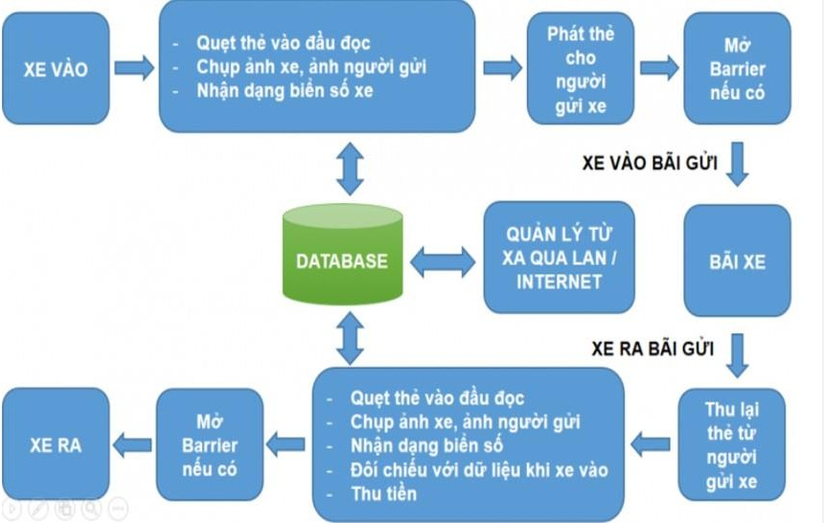

* **Application**
* Driver's photo capturing camera when exiting.
* License plate photo capturing camera when entering.
* Card reader.
* Barrier + Loop Detector (optional).
* Computer installed with SPM Parking Management Software.
* Uninterruptible Power Supply (UPS).

### Display:

* 1. ***Step 1: Login:***

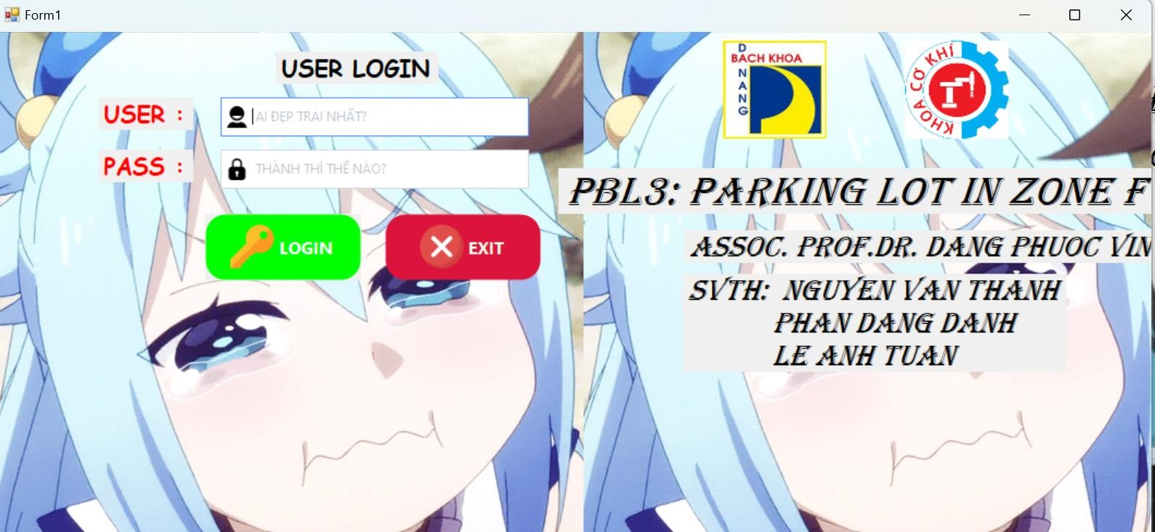

*If you don't have an account:

* The brave will click on the registration link.
* The system will redirect to the registration form for users to sign up for an account.
* Accounts are managed by the Administration, with account management aimed at system security.
  1. ***Step 2: Perform Functions:***

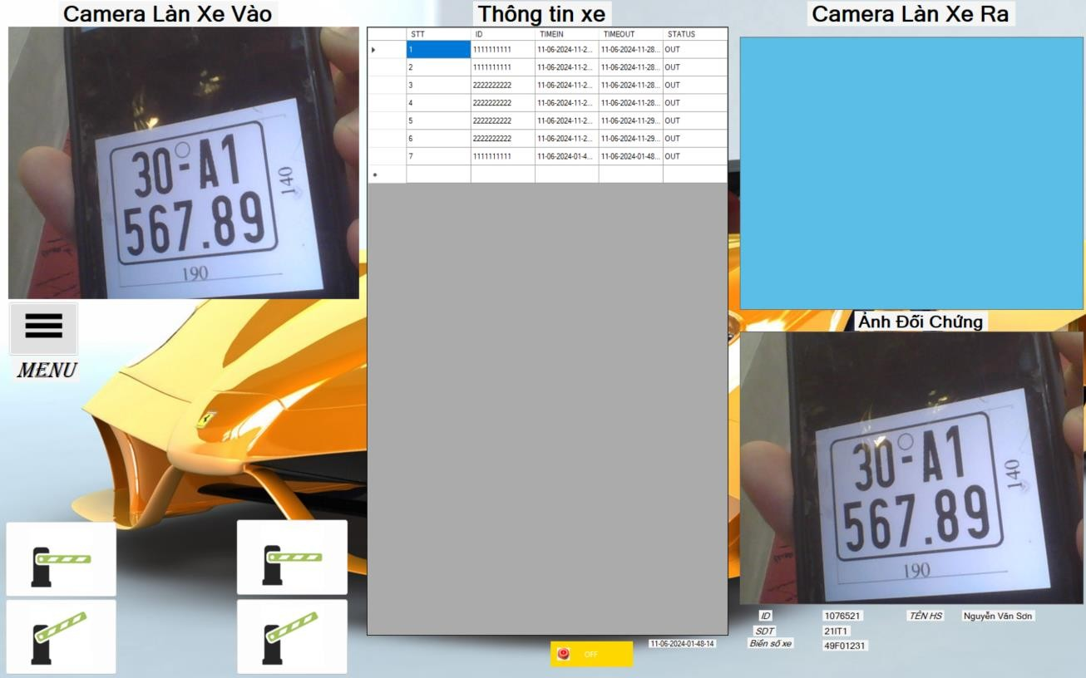

* 1. **Step 3: Customer Registration**

In this step, students will design a customer registration system where information is captured based on each student's unique student ID (MSSV). This process ensures efficient organization and retrieval of student data for future reference and management. By registering essential details linked to their MSSV, such as personal information and course preferences, students can seamlessly engage with the educational platform, streamlining administrative tasks and enhancing user experience.

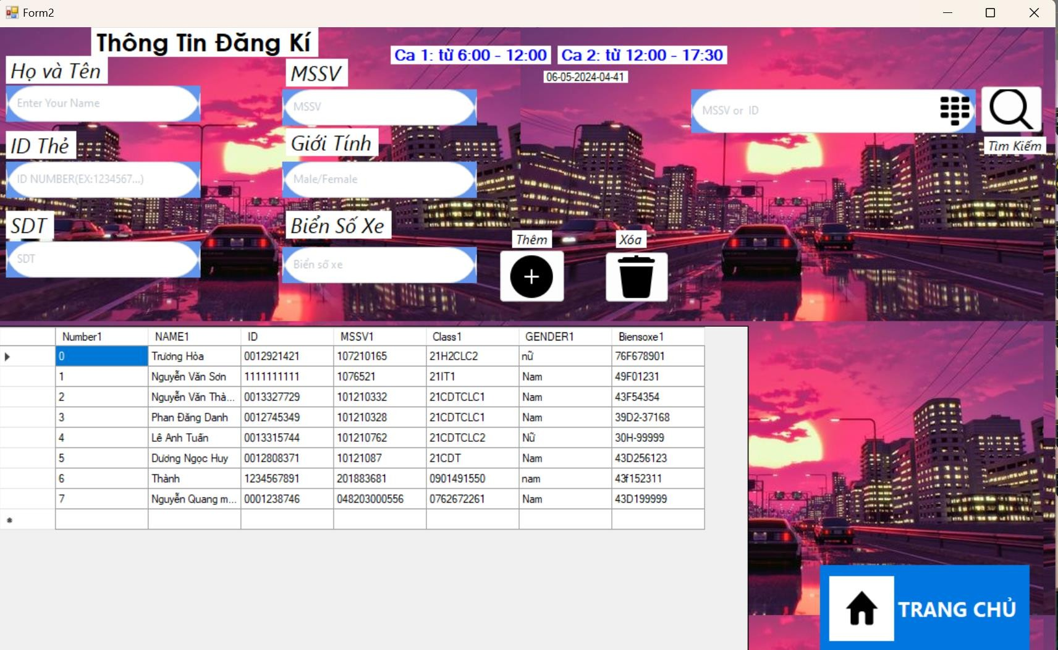

4. CODE

using Emgu.CV;

using Emgu.CV.UI;

using Emgu.CV.Structure;

using System;

using System.Collections.Generic;

using System.ComponentModel;

using System.Data;

using System.Drawing;

using System.Drawing.Imaging;

using System.Linq;

using System.Text;

using System.Threading.Tasks;

using System.Windows.Forms;

using WMPLib;

using Emgu.Util;

using System.IO.Ports;

using System.Data.OleDb;

namespace WindowsFormsApp1

{

public partial class chuongtrinh : Form

{

Capture _camera;

Capture _camera1;

WMPLib.WindowsMediaPlayer music = new WMPLib.WindowsMediaPlayer();

OleDbConnection conn = new OleDbConnection(@"Provider=Microsoft.Jet.OLEDB.4.0;Data Source=D:\WORK\VIUALSTDUIO\hoanthien\WindowsFormsApp1\WindowsFormsApp1\bin\Debug\thongtinxe.mdb");

OleDbConnection con1 = new OleDbConnection(@"Provider=Microsoft.Jet.OLEDB.4.0;Data Source=D:\WORK\VIUALSTDUIO\hoanthien\WindowsFormsApp1\WindowsFormsApp1\bin\Debug\thongtinxe.mdb");

public chuongtrinh()

{

InitializeComponent();

this.KeyPreview = true;

// Gán sự kiện KeyPress cho Form

/* this.KeyPress += new KeyPressEventHandler(chuongtrinh_KeyPress);*/

}

static int clickCount = 0;

private void pictureBox1_Click(object sender, EventArgs e)

{

}

private void thoat1_Click(object sender, EventArgs e)

{

this.Close();

Form1 f = new Form1();

f.Show();

}

private void button1_Click_1(object sender, EventArgs e)

{

}

private void _camera_ImageGrabbed(object sender, EventArgs e)

{

try

{

Mat frame = new Mat();

_camera.Retrieve(frame);

pictureBox1.Image = frame.ToImage<Bgr, byte>().Bitmap;

}

catch {

}

}

private void _camera_ImageGrabbed1(object sender, EventArgs e)

{

Mat frame = new Mat();

_camera1.Retrieve(frame);

pictureBox2.Image = frame.ToImage<Bgr, byte>().Bitmap;

}

private void save_Click(object sender, EventArgs e)

{

string Filename = DateTime.Now.ToString("dd-MM-yyyy-hh-mm-ss") + ".png";

string Foldername = @"D:\WORK\VIUALSTDUIO\hoanthien\anh\";

pictureBox1.Image.Save(Foldername + Filename, ImageFormat.Png);

MessageBox.Show("SAVED", "THONG BAO", MessageBoxButtons.OK, MessageBoxIcon.Information);

}

private void button5_Click(object sender, EventArgs e)

{

music.URL = "123.mp3";

music.controls.play();

}

private void guna2Button1_Click(object sender, EventArgs e)

{

music.controls.stop();

/* _camera.Pause();//not working

_camera.Stop();//not working

_camera.Dispose();//worked b*/

}

private void guna2Button2_Click(object sender, EventArgs e)

{

music.URL = "1234.mp3";

}

private void button3_Click(object sender, EventArgs e)

{

}

private void button1_Click(object sender, EventArgs e)

{

}

private void button4_Click(object sender, EventArgs e)

{

}

private void thoat1_Click_1(object sender, EventArgs e)

{

this.Close();

Form1 f = new Form1();

f.Show();

}

private void pictureBox2_Click(object sender, EventArgs e)

{

}

private void pictureBox3_Click(object sender, EventArgs e)

{

/*anhxe.Image=new Bitmap(Application.StartupPath+)*/

}

private void anhxevao_Click(object sender, EventArgs e)

{

}

private void guna2Button2_Click_1(object sender, EventArgs e)

{

chuongtrinh f = new chuongtrinh();

f.Show();

this.Hide();

}

private void guna2Button6_Click(object sender, EventArgs e)

{

sinhvien f = new sinhvien();

f.Show();

this.Hide();

}

private void guna2Button8_Click(object sender, EventArgs e)

{

timkiem f = new timkiem();

f.Show();

this.Hide();

}

private void guna2Button7_Click(object sender, EventArgs e)

{

information f = new information();

f.Show();

this.Hide();

}

private void button1_Click_2(object sender, EventArgs e)

{

/* OleDbCommand cmd = new OleDbCommand("Insert into thongtinxe(idthexe1,thoigianvao1,thoigianvao2) Values(@idxe1,@timevao1,@timevao2)", conn);

cmd.Parameters.AddWithValue("@idxe1", fullname1.Text);

cmd.Parameters.AddWithValue("@timevao1", label4.Text);

conn.Open();

cmd.ExecuteNonQuery();

conn.Close();

MessageBox.Show("OK", "THONG BAO");

chuongtrinh f = new chuongtrinh();

f.Show();

this.Hide();

*/

}

private void textBox1_TextChanged(object sender, EventArgs e)

{

}

void showData()

{

DataTable dt = loadData("SELECT STT, ID, TIMEIN, TIMEOUT ,STATUS FROM thongtinxe");

dataGridView1.DataSource = dt;

}

private bool panelVisible = false;

private void chuongtrinh_Load(object sender, EventArgs e)

{

btnOff.Visible = false;

btnOn.Visible = false;

button5.Visible = false;

button4.Visible = false;

serialPort1.Open();

button7.Hide();

guna2PictureBox3.Hide();

/* label4.Visible = true;

label6.Visible = true;*/

guna2Panel2.Visible = false;

cam(0,2);

fullname1.Hide();

label1.Text = DateTime.Now.ToString("dd-MM-yyyy-hh-mm-ss");

label8.Hide();

conn.Open();

OleDbCommand cmd = conn.CreateCommand();

cmd.CommandType = CommandType.Text;

cmd.CommandText = "SELECT STT, ID, TIMEIN, TIMEOUT, STATUS FROM thongtinxe";

cmd.ExecuteNonQuery();

DataTable dt = new DataTable();

OleDbDataAdapter dp = new OleDbDataAdapter(cmd);

conn.Close();

dp.Fill(dt);

dataGridView1.DataSource = dt;

// Đọc ảnh từ tệp tin và hiển thị trên PictureBox

/* hinhanhxevao.Image = Image.FromFile(@"D:\WORK\VIUALSTDUIO\hoanthien\anh\1.png");*/

}

private void cam(int i,int o)

{

_camera = new Capture(i);

_camera.ImageGrabbed += _camera_ImageGrabbed;

_camera.Start();

_camera1 = new Capture(o);

_camera1.ImageGrabbed += _camera_ImageGrabbed1;

_camera1.Start();

}

private void button2_Click_1(object sender, EventArgs e)

{

/* OleDbCommand cmd = new OleDbCommand("Insert into thongtinxe(idthexe1,thoigianvao1,thoigianvao2) Values(@idxe1,@timevao1,@timevao2)", conn);

cmd.Parameters.AddWithValue("@idxe1", fullname1.Text);

cmd.Parameters.AddWithValue("@timevao1", label1.Text);

conn.Open();

cmd.ExecuteNonQuery();

conn.Close();

MessageBox.Show("OK", "THONG BAO");

chuongtrinh f = new chuongtrinh();

f.Show();

this.Hide();*/

}

private void datetime4_ValueChanged(object sender, EventArgs e)

{

}

private void label1_Click(object sender, EventArgs e)

{

}

private void timer1_Tick(object sender, EventArgs e)

{

}

private void guna2Button4_Click(object sender, EventArgs e)

{

/* string tagid = fullname1.Text;

if (tagid.Length > 10)

{

OleDbCommand cmd = new OleDbCommand("Insert into thongtinxe(ID,TIMEIN,STATUS) Values(@idxe1,@timevao1,@timevao2)", conn);

cmd.Parameters.AddWithValue("@idxe1", fullname1.Text);

cmd.Parameters.AddWithValue("@timevao1", label1.Text);

conn.Open();

cmd.ExecuteNonQuery();

conn.Close();

string Filename = fullname1.Text + ".png";

string Foldername = @"D:\WORK\VIUALSTDUIO\hoanthien\anh\";

pictureBox1.Image.Save(Foldername + Filename, ImageFormat.Png);

MessageBox.Show("SAVED AND CHECKED IN", "THÔNG BÁO", MessageBoxButtons.OK, MessageBoxIcon.Information);

chuongtrinh f = new chuongtrinh();

f.Show();

this.Hide();

}*/

}

private void guna2Button3_Click(object sender, EventArgs e)

{

/* try

{

string Filename = checkout22.Text + ".png";

string Foldername = @"D:\WORK\VIUALSTDUIO\hoanthien\anh\";

hinhanhxevao.Image = Image.FromFile(Foldername + Filename);

*//* *hinhanhxevao.Image = Image.FromFile(@"D:\WORK\VIUALSTDUIO\hoanthien\anh\1.png"); *//*

// Kiểm tra xem tệp tin có tồn tại không trước khi đọc

}

catch

{

MessageBox.Show("Có lỗi","THOONG BAO");

}

*/

}

private void contextMenuStrip1_Opening(object sender, CancelEventArgs e)

{

}

private void label5_Click(object sender, EventArgs e)

{

}

private void guna2PictureBox1_Click(object sender, EventArgs e)

{

}

private void label6_Click(object sender, EventArgs e)

{

}

int checkOut(string tagid)

{

/* if (serialPort1.IsOpen)

serialPort1.Write("2");*/

DataTable dt = loadData("select * from thongtinxe where status = 'IN' and ID = '" + tagid + "'");

if (dt.Rows.Count == 0) return 0;

try

{

serialPort1.Write("3");

string datetime2 = DateTime.Now.ToString("dd-MM-yyyy-hh-mm-ss");

executeNonQuery("UPDATE thongtinxe SET TIMEOUT = '" + datetime2 + "' WHERE status = 'IN' AND ID ='" + tagid + "'");

string timein = (string)dt.Rows[0]["TIMEIN"];

string Foldername = @"D:\WORK\VIUALSTDUIO\hoanthien\anh\";

string nameAnh = tagid + "_" + timein;

// MessageBox.Show(nameAnh);

//Console.WriteLine(Foldername + nameAnh);

hinhanhxevao.Image = Image.FromFile(Foldername + nameAnh + ".png");

}

catch { }

executeNonQuery("Update thongtinxe set STATUS = 'OUT' where ID='" + tagid + "'");

var messageBox = new Form() ;

var timer = new Timer();

timer.Tick += (timerSender, timerEventArgs) =>

{

messageBox.Close();

timer.Stop();

};

timer.Interval = 700;

timer.Start();

MessageBox.Show(messageBox,"Đã checkout Thẻ " + tagid);

hienthithongtin1();

fullname1.Text = "";

showData();

return 1;

}

int executeNonQuery(string querry)

{

try

{

conn.Open();

OleDbCommand cmd = conn.CreateCommand();

cmd.CommandText = querry;

int i = cmd.ExecuteNonQuery();

conn.Close();

return i;

}

catch

{

try

{

conn.Close();

}

catch { }

}

return 0;

}

DataTable loadData(string querry)

{

DataTable dt = new DataTable();

try

{

conn.Open();

OleDbCommand cmd = conn.CreateCommand();

cmd.CommandText = querry;

cmd.ExecuteNonQuery();

conn.Close();

OleDbDataAdapter dp = new OleDbDataAdapter(cmd);

dp.Fill(dt);

}catch {

try

{

conn.Close();

}

catch { }

}

return dt;

}

void checkIn(string tagid)

{

music.URL = "123456.mp3";

music.controls.play();

if (serialPort1.IsOpen)

serialPort1.Write("4");

clickCount++;

fullname1.Focus();

string datetime2 = DateTime.Now.ToString("dd-MM-yyyy-hh-mm-ss");

executeNonQuery("Insert into thongtinxe(STT,ID,TIMEIN,STATUS) Values('"+getMaxSTT()+ "','" +tagid+"','"+datetime2+"','IN')");

string Filename = tagid +"_"+ datetime2 +".png";

string Foldername = @"D:\WORK\VIUALSTDUIO\hoanthien\anh\";

pictureBox1.Image.Save(Foldername + Filename , ImageFormat.Png);

// Hiển thị hộp thoại thông báo tùy chỉnh

var messageBox = new Form()

{

Size = new Size(0, 0),

StartPosition = FormStartPosition.Manual,

Location = new Point(-1000, -1000)

};

var timer = new Timer();

timer.Tick += (timerSender, timerEventArgs) =>

{

guna2PictureBox3.Hide(); // Đóng hộp thoại thông báo

timer.Stop(); // Dừng timer

};

timer.Interval = 500; // 0.5 giây

timer.Start(); // Bắt đầu đếm thời gian

fullname1.Text = "";

guna2PictureBox3.Show();

/* MessageBox.Show(messageBox, "SAVED AND CHECKED IN", "THÔNG BÁO");*/

showData();

hienthithongtin2();

/* chuongtrinh f = new chuongtrinh();

f.Show();

this.Hide();*/

}

int getMaxSTT()

{

DataTable d = loadData("SELECT*FROM thongtinxe");

int stt = 0;

foreach(DataRow r in d.Rows)

{

int temp = int.Parse((string)r["STT"]);

if (stt <temp) stt = temp;

}

return stt + 1;

}

private void fullname1_TextChanged(object sender, EventArgs e)

{

label8.Text = clickCount.ToString();

string tagid = fullname1.Text;

if (tagid.Length != 10) return;

if (checkOut(tagid)==0)

checkIn(tagid);

/* try

{

string Filename1 = fullname1.Text + ".png";

string datetime1 = DateTime.Now.ToString("dd-MM-yyyy-hh-mm-ss");

string Foldername1 = @"D:\WORK\VIUALSTDUIO\hoanthien\anh\";

hinhanhxevao.Image = Image.FromFile(Foldername1 + datetime1 + Filename1);

}

catch { }*/

}

private void checkout22_TextChanged(object sender, EventArgs e)

{

/* string tagid = checkout22.Text;

if (tagid.Length > 9)

{

try

{

string Filename = checkout22.Text + ".png";

string Foldername = @"D:\WORK\VIUALSTDUIO\hoanthien\anh\";

hinhanhxevao.Image = Image.FromFile(Foldername + Filename);

}

catch

{

MessageBox.Show("Có lỗi", "THOONG BAO");

}

}

}

private void hienthithongtin1() {

con1.Open();

OleDbCommand cmd = con1.CreateCommand();

cmd.CommandType = CommandType.Text;

cmd.CommandText = "select NAME1,MSSV1,Class1,Biensoxe1 from sinhvien where ID='" + fullname1.Text + "'";

cmd.ExecuteNonQuery();

DataTable dt = new DataTable();

OleDbDataAdapter dp = new OleDbDataAdapter(cmd);

dp.Fill(dt);

string guestText = "GUEST";

label12.Text = guestText;

if (dt.Rows.Count > 0)

{

/*label10.Text = dt.Rows[0]["ID"].ToString();*/

label4.Text = dt.Rows[0]["NAME1"].ToString();

label12.Text = dt.Rows[0]["MSSV1"].ToString();

label13.Text = dt.Rows[0]["Class1"].ToString();

label14.Text = dt.Rows[0]["Biensoxe1"].ToString();

}

else

{

}

con1.Close();

}

private void hienthithongtin2()

{

string guestText = "NONE";

label12.Text = guestText;

label4.Text = guestText;

label12.Text = guestText;

label13.Text = guestText;

label14.Text = guestText;

}

private void fullname1_KeyPress(object sender, KeyPressEventArgs e)

{

}

private void chuongtrinh_KeyPress(object sender, KeyPressEventArgs e)

{

fullname1.Text += e.KeyChar;

fullname1.Focus();

e.Handled = true;

}

private void chuongtrinh_KeyDown(object sender, KeyEventArgs e)

{

}

private void button1_Click_3(object sender, EventArgs e)

{

f.Show();

button7.Visible = !panelVisible;

guna2Panel2.Visible = !panelVisible;

panelVisible = !panelVisible;

button4.Visible = !panelVisible;*//*

button5.Visible = !panelVisible;*/

}

private void thoat1_Click_2(object sender, EventArgs e)

{

this.Close();

Form1 f = new Form1();

f.Show();

}

private void guna2Button8_Click_1(object sender, EventArgs e)

{

btnOff.Visible = !panelVisible;

button5.Visible = !panelVisible;

btnOn.Visible = !panelVisible;

button4.Visible = !panelVisible;

panelVisible = !panelVisible;

}

private void guna2Button7_Click_1(object sender, EventArgs e)

{

information f = new information();

f.Show();

this.Hide();

}

private void guna2Button6_Click_1(object sender, EventArgs e)

{

sinhvien f = new sinhvien();

f.Show();

this.Hide();

}

private void guna2Button2_Click_2(object sender, EventArgs e)

{

chuongtrinh f = new chuongtrinh();

f.Show();

this.Hide();

}

private void button2_Click(object sender, EventArgs e)

{

/*conn.Open();

OleDbCommand cmd = conn.CreateCommand();

cmd.CommandType = CommandType.Text;

cmd.CommandText = "select *from sinhvien where ID='" + guna2TextBox1.Text + "' or MSSV1='" + guna2TextBox1.Text + "'";

cmd.ExecuteNonQuery();

DataTable dt = new DataTable();

OleDbDataAdapter dp = new OleDbDataAdapter(cmd);

dp.Fill(dt);

dataGridView1.DataSource = dt;

conn.Close();*/

}

private void button3_Click_1(object sender, EventArgs e)

{

Form2 f = new Form2();

this.Hide();

f.Show();

}

private void btnCom_Click(object sender, EventArgs e)

{

}

private void button2_Click_3(object sender, EventArgs e)

{

serialPort1.Open();

}

private void btnOn_Click(object sender, EventArgs e)

{

if (serialPort1.IsOpen)

serialPort1.Write("3");

}

private void btnNoCom_Click(object sender, EventArgs e)

{

serialPort1.Close();

}

private void btnOff_Click(object sender, EventArgs e)

{

serialPort1.Write("2");

}

private void guna2TextBox1_TextChanged_1(object sender, EventArgs e)

{

}

private void button4_Click_1(object sender, EventArgs e)

{

serialPort1.Write("3");

}

private void button5_Click_1(object sender, EventArgs e)

{

serialPort1.Write("4");

}

private void label13_Click(object sender, EventArgs e)

{

}

private void button6_Click(object sender, EventArgs e)

{/*

try

{

conn.Open();

OleDbCommand cmdUpdate = conn.CreateCommand();

cmdUpdate.CommandType = CommandType.Text;

cmdUpdate.CommandText = "UPDATE thongtinxe SET Tiền = TIMEOUT - TIMEIN";

int rowsUpdated = cmdUpdate.ExecuteNonQuery();

conn.Close();

MessageBox.Show("Updated " + rowsUpdated + " rows successfully.");

}

catch (OleDbException ex)

{

// Handle OleDbException

MessageBox.Show("Error: " + ex.Message);

} }

private void button8_Click(object sender, EventArgs e)

{

}

private void button6_Click_1(object sender, EventArgs e)

{

music.URL = "1237.mp3";

music.controls.play();

}

private void button7_Click(object sender, EventArgs e)

{

music.URL = "1237.mp4";

music.controls.play();

}

private void guna2Panel2_Paint(object sender, PaintEventArgs e)

{

}

}

}

## PART IV: PRODUCT AND SOFTWARE MANUALS

# BIBLIOGRAPHY

1. Dang Phuoc Vinh, Vo Nhu Thanh, "PIC microcontroller engineering textbook", Construction Publishing House, 2019.
2. TS. Dang Phuoc Vinh, MSc. Tran Quang Khai, PhD. Doan Le Anh, PhD. Vo Nhu Thanh, PhD. Pham Anh Duc, "Programming PIC microcontrollers and peripherals", Science and Technology Publishing House, 2021.